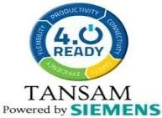

AI-Enabled IoT Smart Anganwadi System for Real-Time ICDS Monitoring and Malnutrition Risk Prediction

NAME: S.Vajitha Bervin
TEAM MEMBERS: S.Srimathi Mangai
T.Keerthana

TABLE OF CONTENTS

1.Abstract………………..…………………………………………...……………..…...3
2.Introduction………………………………………………………….….……………4
3.Problem Statement……………………………………………………..…………………….…….4
4.Objectives………………………………………………………………..……...........5
5.Literature Review……………….. …..…..……………………….5
6.Need For Smart Anganwadi System…………………..…6
7. Working Principle....
...................................7
8.Components & roles………………...……..…10
9.Circuit diagram ……………………………………………………………………………………..13
10.Code …………………………….………………………………………………........................13
11.Advantages………...……………………………………………………….........................19
12.Applications………...……………………………………………………………………………..19
13.Future Enhancement……..……………………………………………………………………20
14.Conclusion……………..…………………………………………….……………………………..21
15.References…….……………….………………………………..…………………………………21

1.Abstract
The Integrated Child Development Services (ICDS) scheme is India’s largest early childhood care program, providing nutrition and growth monitoring for children through Anganwadi centres. However, many centres still depend on manual measurement of height, weight, and attendance, resulting in inaccurate data, delayed reporting, and limited visibility for ICDS officials. These challenges slow down early detection of malnutrition and affect timely decision-making.
This project presents an AI-enabled IoT Smart Anganwadi System designed to automate growth monitoring and support real-time ICDS supervision. The system integrates ultrasonic height sensing, load-cell-based weight measurement (HX711), and a digital attendance module, all connected to an ESP32 microcontroller. Sensor readings are processed at the edge to calculate BMI accurately, generate health status, and detect abnormalities instantly. Improved logic in the updated model enables dynamic analysis of BMI trends, underweight alerts, and early detection of nutritional decline.
All data—height, weight, BMI, attendance, and risk level—is transmitted securely to
ThingSpeak Cloud, while a live dashboard on Blynk IoT allows Anganwadi staff and ICDS supervisors to monitor each child’s status in real time. An integrated buzzer-based alert mechanism notifies caregivers whenever a child falls below recommended growth levels.
A lightweight AI model classifies children into Normal, Risk, and Critical categories based on ICDS growth deviation standards. This strengthens field monitoring by enabling predictive insights rather than reactive reporting. The solution aligns with national initiatives such as Poshan Abhiyaan, Digital India, and Tamil Nadu’s e-Governance framework, supporting a data-driven approach to public health.
With a prototype cost of under ₹3000, the system is practical, scalable, and suitable for phased deployment across rural and urban Anganwadi centres. By unifying embedded electronics, wireless communication, cloud-based analytics, and AI prediction, the project transforms traditional Anganwadis into intelligent child health monitoring nodes, enhancing transparency, efficiency, and the effectiveness of the ICDS mission.

2.Introduction
India’s Integrated Child Development Services (ICDS) scheme is one of the world’s largest community-based programmes aimed at improving the health and nutrition of children under six years of age. Anganwadi centres play a crucial role by providing growth monitoring, supplementary nutrition, and early education. However, the majority of centres still rely on manual processes using notebooks and registers.
Manual height and weight entry often results in mistakes, delays, and inconsistent records. Since monthly data is usually entered in bulk, real-time visibility for ICDS supervisors is extremely limited. Early detection of malnutrition becomes difficult, affecting timely medical intervention for children.
In today’s Digital India era, manual monitoring is outdated and inefficient. There is a need for an intelligent, automated, and connected system that continuously monitors each child and instantly identifies abnormal patterns in growth.

IoT (Internet of Things) provides a powerful solution for continuous health monitoring by connecting sensors, devices, and cloud-based dashboards. When IoT is combined with Artificial Intelligence (AI), the system becomes capable of analysing growth trends, predicting risk, and alerting caregivers before a problem becomes serious.
This project introduces an AI-enabled IoT Smart Anganwadi Monitoring System that automatically collects measurements using sensors, processes the data using an ESP32 microcontroller, uploads the information to the cloud, and applies intelligent risk prediction models to classify children into Normal, Risk, and Critical categories.
This system supports the national goals of Poshan Abhiyaan, Digital India, and smart governance by providing transparency, accuracy, and data-driven decisions to the ICDS framework.

3.Problem Statement

Anganwadi centers still depend on manual methods to record child health parameters such as height, weight, and nutrition status.
These manual processes often lead to delays, data entry errors, and lack of real-time monitoring.
Because of this, early signs of malnutrition remain unnoticed, and timely intervention becomes difficult for ICDS workers.
Therefore, there is a need for a smart, automated IoT system that can accurately measure child growth parameters, calculate BMI, upload data to a cloud platform, and use AI to predict malnutrition risk in real time.

4.Objectives
- To automate the measurement of child growth parameters such as height and weight using IoT-based sensors.
- To calculate BMI automatically and classify the nutrition level of each child in real time.
- To upload all health data to cloud platforms like ThingSpeak and Blynk for continuous monitoring by Anganwadi workers.
- To develop an AI-based prediction model that identifies potential malnutrition risk early.
- To reduce manual errors and delays in the current ICDS data recording system.
- To provide a simple dashboard interface for real-time viewing of each child’s health status.
- To support early intervention by generating alerts for underweight, overweight, and at-risk children.

5.Literature Review/Existing System
Anganwadi centers under the ICDS scheme mainly rely on manual methods to measure and record child health data. Height and weight are usually entered in registers, and the nutrition status is assessed later by supervisors. This traditional system has several limitations:

1. Manual Measurement Methods
Growth parameters are measured using basic tools like measuring tapes and analog weighing scales.
Accuracy depends on the operator, leading to frequent errors.

2. Paper-Based Record Keeping
Health details are written in notebooks or registers.
Records are often incomplete, misplaced, or damaged over time.
Difficult to access previous data for comparison or growth tracking.

3. No Real-Time Monitoring
Data reaches ICDS supervisors only during monthly or weekly visits.
Malnutrition symptoms may be detected late, reducing the chance of early intervention.

4. Lack of Data Analytics
Manual data cannot provide insights like BMI trends, growth charts, or risk predictions.
Supervisors cannot monitor multiple centers efficiently.

5. Existing Digital Tools Are Limited
Some mobile applications exist for ICDS workers, such as CAS (Common Application Software).
These depend on manual entry by workers, and do not integrate with sensors or automatic AI predictions.
No automated cloud-based growth tracking is available.

The existing system lacks automation, accuracy, real-time monitoring, and prediction capability.
This creates a strong need for an IoT + AI integrated solution that can continuously monitor child health and predict malnutrition risk early.

6.Need For Smart Anganwadi System
The current manual growth-monitoring process in Anganwadi centres is slow, errorprone, and provides very limited support for early detection of malnutrition. To overcome these challenges, there is a strong need for an automated, intelligent, IoTbased health monitoring solution.
- Need for Accurate Measurements
Children’s height, weight, and BMI must be measured precisely to identify growth deviations early. Manual tools often produce inconsistent readings, making it difficult to rely on the data.
- Need for Real-Time Monitoring
ICDS supervisors cannot visit every center frequently. A real-time dashboard helps them monitor hundreds of children instantly, enabling quick decision-making from anywhere.
- Need for Early Malnutrition Prediction
Delayed detection of stunting or underweight leads to severe health consequences. An AI-based prediction system helps identify risk levels before they become critical.
- Need to Reduce Manual Workload
Anganwadi workers spend significant time writing records, calculating BMI, and preparing monthly reports. Automation reduces their workload and improves efficiency.
- Need for Transparent Data Storage
Cloud-based storage ensures data cannot be lost, damaged, or manipulated. Supervisors get complete visibility of each child’s growth history.
- Need for Alerts and Notifications
Immediate alerts for severe malnutrition, slow growth, or irregular attendance help caregivers provide quick support to vulnerable children.
- Need for Integration With National Digital Programs
The solution supports Poshan Abhiyaan, Digital India, and e-Governance initiatives by enabling data-driven decision-making and modernizing traditional Anganwadi operations.

A system that combines IoT sensing, AI analysis, and cloud monitoring is essential to modernize ICDS tracking, improve accuracy, and protect children from malnutrition at an early stage.

7.Working Principle
The AI-Enabled IoT Smart Anganwadi System operates by continuously collecting, processing, and transmitting child health data using embedded sensors, an ESP32 controller, cloud platforms, and an AI-based classification model. The overall working principle is described below:
- Sensor-Based Data Collection
The system uses two primary sensors:
Ultrasonic Sensor → Measures the child’s height.
Load Cell with HX711 Amplifier → Measures the child’s weight.
When a child stands on the platform, the sensors generate analog/digital signals representing height and weight.
- Local Processing & BMI Calculation
The ESP32 microcontroller receives the sensor readings and converts them into usable values.
It then performs:
Height conversion (cm → meters)
BMI Calculation using the formula:
Attendance detection (present/absent)
This edge computing ensures fast and reliable data processing within the device itself.
- AI-Based Health Classification
The system applies a lightweight AI logic using Z-Score values to classify children into three categories:
  - Normal
  - Moderate Risk
  - Severe Malnutrition
This helps in early prediction of growth deviation rather than waiting for symptoms to appear.
- Alert Mechanism
Based on the health status:
  - Severe Malnutrition → Long buzzer alert
  - Moderate Risk → Short buzzer alert
  - Slow Growth or Irregular Attendance → Warning messages
This ensures caregivers receive instant notifications.
- IoT Cloud Transmission (ThingSpeak)
After local processing, data packets containing:
  - Height
  - Weight
  - BMI
  - Z-Score
  - Attendance are uploaded to ThingSpeak Cloud using HTTP requests.
The cloud platform stores the data chronologically and displays visual graphs for trend analysis.
- Real-Time Dashboard Display (Blynk IoT)
At the same time, the ESP32 sends data to the Blynk Android Dashboard, giving Anganwadi staff:
  - Live height/weight values
  - Real-time BMI
  - Health condition
  - Daily attendance
This helps supervisors monitor children instantly from any location.
- Continuous Monitoring Through RTOS Tasks
The ESP32 runs multiple tasks in parallel using FreeRTOS, including:
  - Sensor reading
  - Alert control
  - Blynk communication
  - Cloud uploading
  - Serial display
This parallel task operation ensures smooth and uninterrupted functioning.

8.Components and Roles
The AI-Enabled IoT Smart Anganwadi System consists of several hardware and software components that work together to automate height, weight, BMI, and health-status monitoring. Each component plays a specific role in ensuring accurate sensing, intelligent decision-making, and real-time data access.

8.1 Hardware Components
1. ESP32 Microcontroller Role:
- Acts as the central processing unit of the system.
- Collects sensor values (height, weight, attendance).
- Performs BMI and Z-score calculations.
- Runs AI classification logic.
- Sends data to ThingSpeak Cloud and Blynk Dashboard.
- Handles buzzer alerts and manages multiple tasks via FreeRTOS.
Why ESP32?
- Built-in Wi-Fi → easy IoT connectivity
- Dual-core processor → supports multitasking
- Low power consumption → suitable for rural Anganwadi centres
2.Ultrasonic Sensor (HC-SR04) Role:
- Measures the child’s height using sound waves.
- Sends ultrasonic pulses and receives the reflected signal.
- Calculates distance (height) based on time-of-flight.
Importance:
Height is one of the two primary parameters required to compute BMI.
3. Load Cell with HX711 Amplifier Role:
- Measures a child’s weight when they stand on the platform.
- Converts tiny pressure changes into measurable electrical signals.
- The HX711 module amplifies and digitizes the signal for the ESP32.
Importance:
Accurate weight data is essential for BMI calculation and malnutrition detection.
4. Attendance Sensor / Switch Role:
- Detects whether the child is present or absent on a given day.
- Sends binary values (0/1) to ESP32.
Implemented:
- Attendance data was simulated during the prototype/simulation stage.
Importance:
- Low attendance is a major contributor to poor nutrition.
- This module helps supervisors track consistency.
5. Buzzer Role:
- Provides real-time alerts based on health status.
- Blynk-based notification alert
Importance:
Instant feedback helps Anganwadi workers take immediate action.
6. Power Supply Module Role:
- Provides stable 5V & 3.3V to ESP32 and sensors.
Importance:
Ensures reliable system operation, especially during continuous monitoring.
7. Measuring Platform / Enclosure Role:
- Child stands on it for weight measurement.
- Height sensor is mounted above.
Importance:
Ensures accuracy, safety, and stability.

8.2 Software Components

1. Wokwi Platform
Role:
• Used to simulate, test, and debug the ESP32-based Smart Anganwadi System virtually.
• Integrates sensors such as ultrasonic sensor, load cell with HX711 amplifier, and RFID module.
• Displays outputs such as height, weight, BMI, Z-score, attendance, and risk level during simulation.
Importance:
• Provides a virtual environment to test the system without physical hardware.
• Helps reduce development cost and identify errors before real-time implementation.
Platform Role:
• Acts as a simulation platform for validating sensor connections, system functionality, and real-time outputs.
Importance:
• Ensures proper system performance and improves reliability before hardware deployment.
2.Blynk IoT Platform
Role:
• Displays real-time data on mobile dashboards.
• Shows height, weight, BMI, Z-score, attendance, and risk level live.
• Enables remote monitoring of child health and attendance records.
Importance:
• Helps Anganwadi workers monitor child growth and nutritional status instantly from anywhere.
• Reduces manual monitoring and improves accessibility of real-time data.
Platform Role:
• Acts as a cloud-based IoT platform for real-time visualization and monitoring of sensor data through mobile devices.
Importance:
• Ensures easy access to child health information and supports quick decision-making for better monitoring.
3. ThingSpeak IoT Cloud Role:
- Stores and visualizes historical data.
- Generates graphs of height, weight, BMI, and risk level.
- Enables remote monitoring for ICDS supervisors.
Importance:
Provides long-term analytics and supports data-driven decisions.
4. FreeRTOS
Future Enhancement:
FreeRTOS-based task scheduling can be introduced to separate sensor acquisition, cloud communication, alert handling and dashboard updates.
Importance:
Makes the system real-time, smooth, and efficient.
5. Cloud API Integration Role:
- HTTP API is used to transmit data to ThingSpeak.
- Blynk Cloud uses virtual pin communication.
Importance:
Enables seamless IoT connectivity and real-time updates.

9.Circuit Diagram

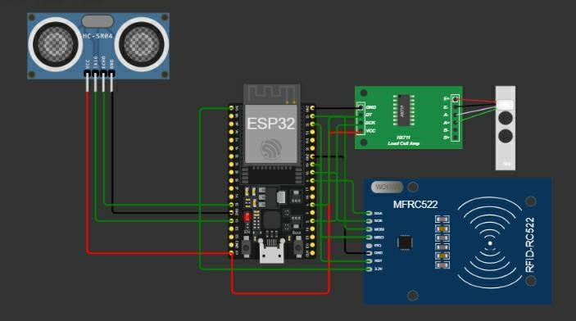

10.Code
#define BLYNK_TEMPLATE_ID "YOUR_TEMPLATE_ID"
#define BLYNK_TEMPLATE_NAME "esp32"
#define BLYNK_AUTH_TOKEN "YOUR_BLYNK_AUTH_TOKEN"

#define BLYNK_PRINT Serial

#include <WiFi.h>
#include <BlynkSimpleEsp32.h>

// ---------- WIFI CONFIGURATION ----------
char ssid[] = "Wokwi-GUEST";
char pass[] = "";

// ---------- THINGSPEAK CONFIGURATION ----------
String apiKey = "YOUR_THINGSPEAK_API_KEY";
const char* server = "api.thingspeak.com";

// ---------- VARIABLES ----------
float height_cm = 100.0;
float weight_kg = 15.0;
float bmi = 0.0;
float zScore = 0.0;
float predictedWeight = 0.0;

String bmiStatus = "";
String riskLevel = "";

int attendance = 0;
bool alertSent = false;

// ---------- BMI CALCULATION ----------
float calculateBMI(float weight, float height) {

float height_m = height / 100.0;

if (height_m <= 0)
return 0;

return weight / (height_m * height_m);
}

// ---------- Z-SCORE CALCULATION ----------
float calculateZScore(float height, float weight) {

// Sample Z-score logic
return (weight - 12.5);
}

// ---------- BMI STATUS ----------
String getBMIStatus(float bmi) {

if (bmi < 14)
return "Severe";

else if (bmi < 15)
return "Moderate";

else if (bmi < 18.5)
return "Underweight";

else
return "Normal";
}

// ---------- SMART PREDICTION ----------
float predictWeight(float height) {

return (height - 100) * 0.9;
}

// ---------- HEALTH RISK ANALYSIS ----------
String getRiskLevel(float actual, float predicted) {

if (actual < predicted - 2)
return "Underweight Risk";

else if (actual > predicted + 2)
return "Overweight";

else
return "Healthy";
}

// ---------- SETUP ----------
void setup() {

Serial.begin(115200);

// WiFi Connection
WiFi.begin(ssid, pass);

Serial.print("Connecting to WiFi");

while (WiFi.status() != WL_CONNECTED) {

delay(500);
Serial.print(".");
}

Serial.println("\nWiFi Connected Successfully!");

// Blynk Initialization
Blynk.begin(BLYNK_AUTH_TOKEN, ssid, pass);

// Random seed for simulation
randomSeed(analogRead(0));
}

// ---------- SEND DATA TO THINGSPEAK ----------
void sendToThingSpeak() {

WiFiClient client;

if (client.connect(server, 80)) {

String postStr = apiKey;

postStr += "&field1=" + String(height_cm);
postStr += "&field2=" + String(weight_kg);
postStr += "&field3=" + String(bmi);
postStr += "&field4=" + String(zScore);
postStr += "&field5=" + String(attendance);
postStr += "&field6=" + String(predictedWeight);

postStr += "\r\n\r\n";

client.print("POST /update HTTP/1.1\n");
client.print("Host: api.thingspeak.com\n");
client.print("Connection: close\n");
client.print("Content-Type: application/x-www-form-urlencoded\n");
client.print("Content-Length: ");
client.print(postStr.length());
client.print("\n\n");

client.print(postStr);

Serial.println("Data Uploaded to ThingSpeak!");
}
}

// ---------- MAIN LOOP ----------
void loop() {

Blynk.run();

// Simulated Sensor Values
height_cm += random(-2, 3);
weight_kg += random(-1, 2);

// Sensor Value Limits
height_cm = constrain(height_cm, 80, 130);
weight_kg = constrain(weight_kg, 10, 25);

// Simulated RFID Attendance
attendance = random(0, 2);

// Calculations
bmi = calculateBMI(weight_kg, height_cm);
zScore = calculateZScore(height_cm, weight_kg);

bmiStatus = getBMIStatus(bmi);

// Smart Prediction Logic
predictedWeight = predictWeight(height_cm);
riskLevel = getRiskLevel(weight_kg, predictedWeight);

// Alert Notification
if ((bmi < 14 || riskLevel == "Underweight Risk") && !alertSent) {

Blynk.logEvent(
"malnutrition_alert",
"Child Health Risk Detected!"
);

alertSent = true;
}

// ---------- SERIAL MONITOR OUTPUT ----------
Serial.println("\n------ SMART ANGANWADI SYSTEM DATA ------");

Serial.print("Height (cm): ");
Serial.println(height_cm);

Serial.print("Weight (kg): ");
Serial.println(weight_kg);

Serial.print("BMI Value: ");
Serial.println(bmi);

Serial.print("Z-Score: ");
Serial.println(zScore);

Serial.print("Attendance: ");
Serial.println(attendance);

Serial.print("Predicted Weight: ");
Serial.println(predictedWeight);

Serial.print("Risk Level: ");
Serial.println(riskLevel);

// ---------- BLYNK DASHBOARD ----------
Blynk.virtualWrite(V0, height_cm);
Blynk.virtualWrite(V1, weight_kg);
Blynk.virtualWrite(V2, bmi);
Blynk.virtualWrite(V3, zScore);
Blynk.virtualWrite(V4, attendance);
Blynk.virtualWrite(V5, bmiStatus);
Blynk.virtualWrite(V6, predictedWeight);
Blynk.virtualWrite(V7, riskLevel);

// ---------- THINGSPEAK ----------
sendToThingSpeak();

delay(15000);
}
Output:
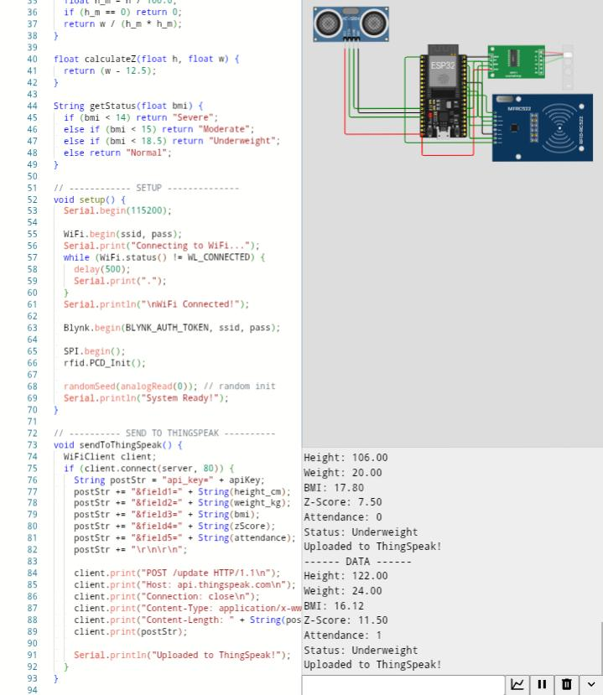

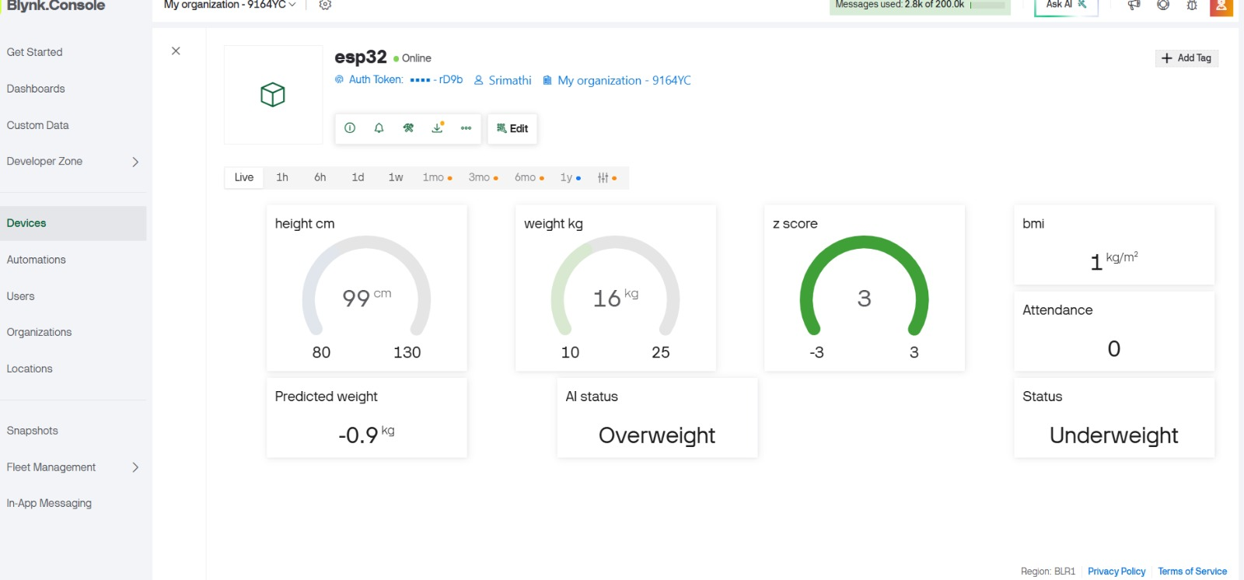
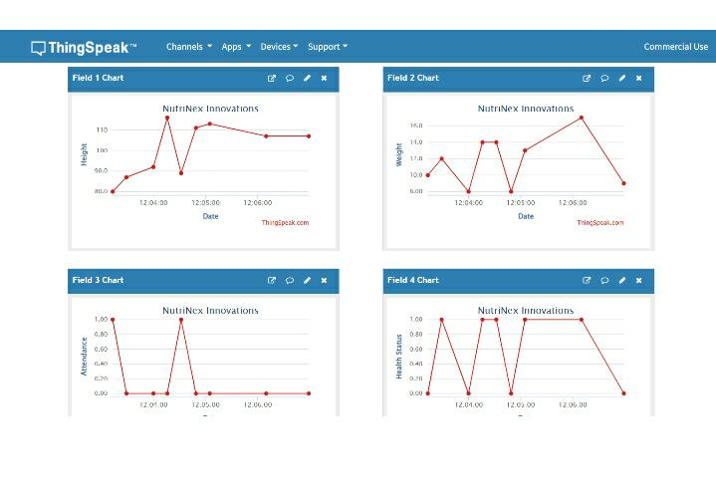

11.Advantages
Accurate Measurements -Automated sensors reduce manual errors in height, weight, and BMI.
Real-Time Monitoring - Data updates instantly on ThingSpeak and Blynk dashboards.
Early Malnutrition Detection - AI predicts Normal / Risk / Critical levels for quick action.
Reduced Workload - No manual calculations or monthly report preparation.
Instant Alerts - Buzzer warns when a child shows underweight or critical growth deviation.
Cloud Storage - Secure, transparent, and easily accessible child health records.
Low-Cost & Scalable - Prototype under 3000, suitable for mass deployment.
Supports Government Programs - Aligns with Poshan Abhiyaan and Digital India.

12.Applications
Anganwadi Centres (ICDS Scheme)
Automated height, weight, BMI, and nutrition-risk monitoring for children aged 06.
Primary Health Centres (PHC)
Digital growth tracking for infants and toddlers during routine health check-ups.
Government Nutrition Programs
Supports Poshan Abhiyaan, Digital India, and child welfare schemes with real-time data.
Schools & Pre-Schools
Useful for monitoring the health status of LKG/UKG school children.
Rural Health Monitoring
Provides continuous, accurate health data in areas with limited medical access.
NGOs & Child Welfare Organizations
Helps NGOs monitor undernourished children and plan corrective programs.
Growth Research & Data Analytics
Enables researchers to study child development trends using cloud-based datasets.

13.Future Enhancement
Integration with Government Portals
Direct auto-upload to ICDS, POSHAN Tracker, and Health Department dashboards.

Mobile App for Parents
A dedicated app to show each child’s growth trend, vaccination reminders, and nutrition tips.

Advanced AI Prediction Model
Using machine learning for more accurate risk detection based on long-term historical data.
Voice Assistance for Anganwadi Workers
Voice instructions (in Tamil/English) to guide workers during measurement.
Solar-Powered Version
To support remote rural Anganwadis with unstable electricity supply.
Integration of Additional Sensors
Adding temperature, SpO,and heart-rate sensors for complete child health profiling.
Offline Data Buffering
System will store data offline and sync automatically when internet becomes available.
Multi-Child ID Management
RFID/QR-based digital profiles for tracking large groups of children easily.

14.Conclusion
The AI-Enabled IoT Smart Anganwadi System successfully replaces manual child growth monitoring with a fully automated, intelligent, and real-time solution. By integrating height and weight sensors, BMI calculation, attendance tracking, cloud connectivity, and AI-based malnutrition prediction, the system ensures accurate data collection and faster decision-making for ICDS supervisors.
This project not only reduces human error but also empowers Anganwadi workers with instant alerts and easy-to-understand dashboards. With its low-cost design and scalable architecture, the system can be deployed across rural as well as urban centres, supporting national missions like Poshan Abhiyaan and Digital India.
Overall, the project transforms traditional Anganwadis into smart health monitoring hubs, enabling early detection of malnutrition and contributing to healthier childhood development for India’s future.

15.References
- World Health Organization (WHO) – Child Growth Standards, BMI-for-age charts and malnutrition classification guidelines.
- Ministry of Women & Child Development, Government of India – ICDS Scheme, Poshan Abhiyaan Mission documents and nutrition monitoring standards.
- ESP32 Technical Documentation, Espressif Systems – Hardware architecture, WiFi connectivity and RTOS task handling.
- ThingSpeak IoT Analytics Platform, MathWorks – Cloud data upload, API usage and channel configuration.
- Blynk IoT Platform Documentation – Dashboard creation, virtual pins, and device communication guidelines.
- HX711 Load Cell Amplifier Datasheet – Weight measurement principles and calibration process.
- Research Papers on IoT-Based Health Monitoring Systems – For edge computing, sensor interfacing, and AI-based risk prediction models.
- Arduino & ESP32 Community Resources – Tutorials for sensor interfacing, cloud integration, and embedded system programming.

